**Our Energy Future**

**Electric Vehicles and Storage Technologies**

There are a few advantages to electric vehicles, including:

* Reduced reliance on limited petroleum products for fuel
* Reduced carbon emissions and improved air quality
* Lower operating costs
* Reduction in GHG production

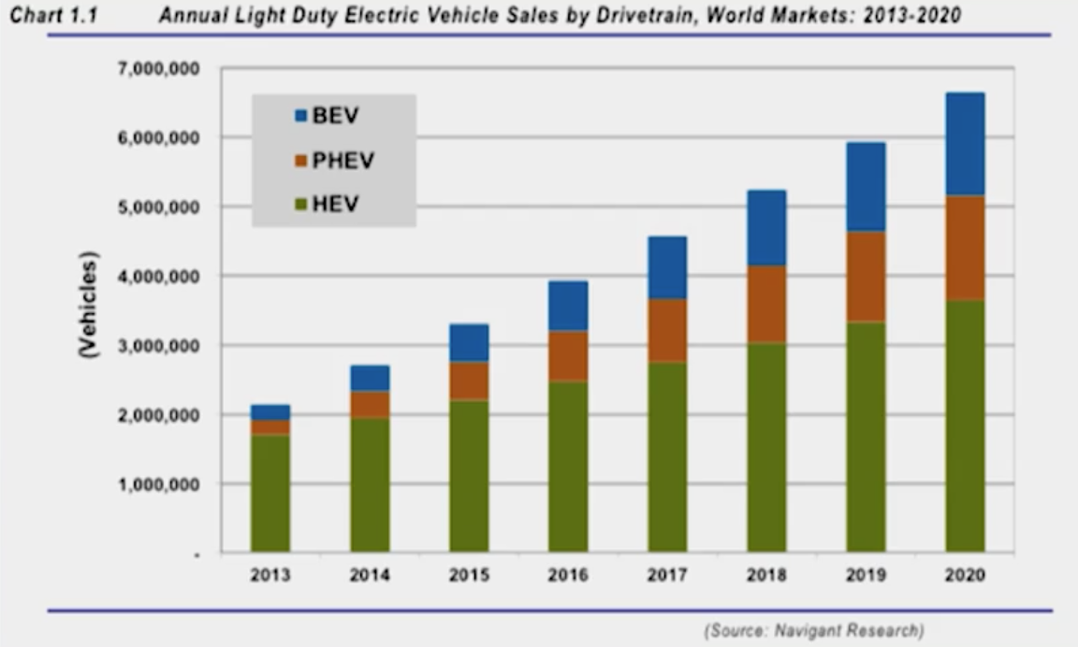In part because of these advantages, electric vehicle sales are projected to grow 225% over the next 7 years.

Another reason for increased adoption is because of regulatory support. A majority of these sales are expected to come from California, which has put legislation in place to encourage consumers to buy EV.

In 2011, President Obama’s administration set a goal of putting 1 million EV on the road by 2015. Part of the legislation included the following benefits:

* $7500 tax credit for consumers
* Grants for communities that encourage EV adoption
* Funding for R&D to drive innovation in advanced battery technology

*Challenges for EV Development*

There are a number of technical challenges associated with EV development and adoption

* Obtaining significant range equivalent to a gas car, ~400 miles. Presently, the range is 100-200 miles
* Lowering the cost of an EV to be equivalent to a petroleum-powered vehicle
* Longer battery life – 10 years/100,000 miles. Presently, it is in the range of 8 years/80,000 miles

Another issue with the battery life of an EV is what to do with the batteries when they have reached the end of their life as an EV battery. EV batteries tend to get retired when they’ve reached ~80% capacity; however, because there is still capacity left in these batteries, that begs the question of what to do with the retired EV battery. One possible solution is to use them in energy storage to enhance reneweable energy adoption

* Developing the EV charging infrastructure

Gas stations are predominant across the nation, but there needs to be a sufficient infrastructure associated with EV. One potential option is through *induction* charging where vehicles can get charged up while parked, without needed to plug into anything.

* Mitigating impact on existing electric power delivery system – Plugging in one EV is the equivalent power demand as powering 4 homes.

Below shows the typical load on the electric grid as it is today. If people charge their cars during the high peak period between 4pm and 5pm, it is a significant increase in load. It would be ideal to charge during the off-peak hours, but this might have effects on the health of the power generation system; it was designed to have a lower load at certain parts of the day in order to extend its usable life. However, charging during off-peak hours would minimize costs to consumers since the price of power decreases along with demand in those times of the day.

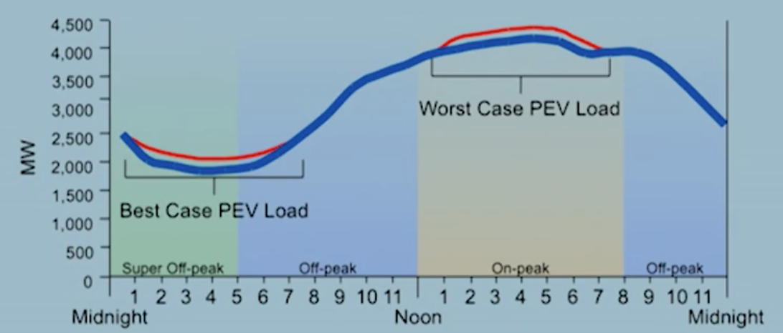

Another way to handle the impact on the grid is through *automated demand response*, which allows the EV to know 1) that it needs to be charges, and 2) when in the day would have the lowest priced energy to charge itself

*Energy Storage*

Energy storage and EV go hand-in-hand because EV are battery-based. Additionally, breakthroughs in energy storage are needed to have renewables become a higher proportion of energy generation. Some of the things that innovative energy storage technologies would allow are:

* Fewer *baseload generation plants* which provide continuous supply of electricity
* Account for the variability of renewable resources like solar and wind
* Account for the difference between renewable generation and customer demand to balance load and generation
* Fast response capability

Allows for mitigation (or *smoothing*) of renewable generation intermittency, along with fast ramping capabilities to maintain constant frequency

* Storage of energy until/when it is needed
* Reduced impact on utility infrastructure by providing ancillary services previously delivered by baseload generation, including:
  + Backup power for emergencies
  + *Spinning reserve* which is energy reserved in case of transmission or generation outages
  + *Frequency regulation* which ramp (up or down) the usage of generator assets
  + *Voltage support* which maintains and ensures the stability of the power flowing to where it needs to go
* Accommodates increased levels of renewable generation

There are different technologies for energy storages, some of the more common ones include:

* Lithium-ion batteries
* Zinc-bromine flow batteries
* Ultracapacitors (used mainly for smoothing of intermittency)
* Thermal energy storage

A key aspect is integrating different aspects of renewable generation to coordinate the *control* and *dispatch* of distributed energy storage resources to maximize system efficiency. As an example of what that could mean in practice, we could use solar forecasting for PV resource production to tell the grid to *control* the amount of energy that gets stored versus dispatched. This would allow for higher efficiency to smooth the amount of solar energy available within the grid.